**Hierarchy of Linux File Management System**

In Linux, files are well managed using file management system. Linux File Management System manage files in hierarchical structure where, “/” (slash) is main directory or root directory (root node in hierarchy). All other directories come this “/” directory

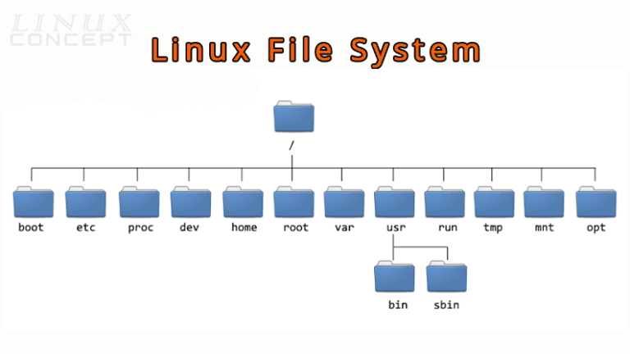

1. **/**

* root of file system.
* Every single file and directory start from the root directory.
* It is the top-level root directory.
* The only root user has the right to write under this directory.

1. **/root**

* It is home directory of root user. In this directory, root user can store its personal files.
* Only root user has right to write under this directory.

1. **/home**

* It stores home directories of Standard/local users.
* Home directories are assigned to each user separately and no other user can access home directories of other users (Except root user).
* Automatically created as “/home” for each user- login directory.

1. **/etc**

* It stores all configuration files of system and services, some security related files, config files related to networking.

1. **/var**

* It stores variable data- files that are expected to change frequently as system runs such as mails, logs, messages, etc. e.g.-/var/log

1. **/bin**

* It stores binary executable files contain executable code/data. These binary executable files are nothing but the commands.
* It is a link of /usr/bin directory. (this directory contains commands that can be used by local users/ other users)

1. **/sbin**

* It stores system binary executable files.
* It is same as bin directory except that only super user has access to execute commands from sbin.
* It is also a link of /usr/sbin directory. (This directory contains commands that only root user can use.)

1. **/boot**

* It stores boot loader program files and all other boot related files.
* It helps to operating system to load correctly so it’s important in computer’s startup process.

1. **/lib**

* Library files information- contains complied code that programs can use to perform various function.
* This directory is actually a soft link of /usr/lib directory.

1. **/lib64**

* Same as that of lib directory and stores 64 architecture library file information.

1. **/usr**

* User related files- is typically used to store user-related program files and data Such as documentary files, manual pages, etc.
* This directory also contain lib, bin, and sbin directory.
* ‘/usr/bin’ contains basic user commands
* ‘/usr/sbin’ contains additional commands for the administrator
* ‘/usr/lib’ contains the system libraries
* ‘/usr/share’ contains documentation or common to all libraries, for example ‘/usr/share/man’ contains the text of the manpage

1. **/sys**

* System information.

1. **/media**

* All removable devices.

1. **/proc**

* Processes information. This directory also stores RAM and CPU related information.

1. **/mnt**

* Standard directory to mount storage device temporary.
* In mnt, temporary files available up to 30 days.

1. **/opt**

* Use for add-on service.
* Contains optional software packages.

1. **/run**

* Contains runtime files and directories that are created and deleted automatically.
* Current Running Devices.

1. **/dev**

* /dev directory stores device information and their block files.
* These files represent physical and virtual devices connected to the system and provide an interface for interacting with them.

1. **/tmp**

* It stores temporary files. It stores temporary data for 10 days.

1. **/srv**

* Contains data for services provided by the system.